ADTA-DAST 5900/5750.501: Applied Natural Language Processing

Project: High-Level Design of the AI dialogue system

By:- Bhawana Rohile, Sarika Gaind, Aamir Omar

- List of all significant dialogue flows that the AI dialogue system aims to serve

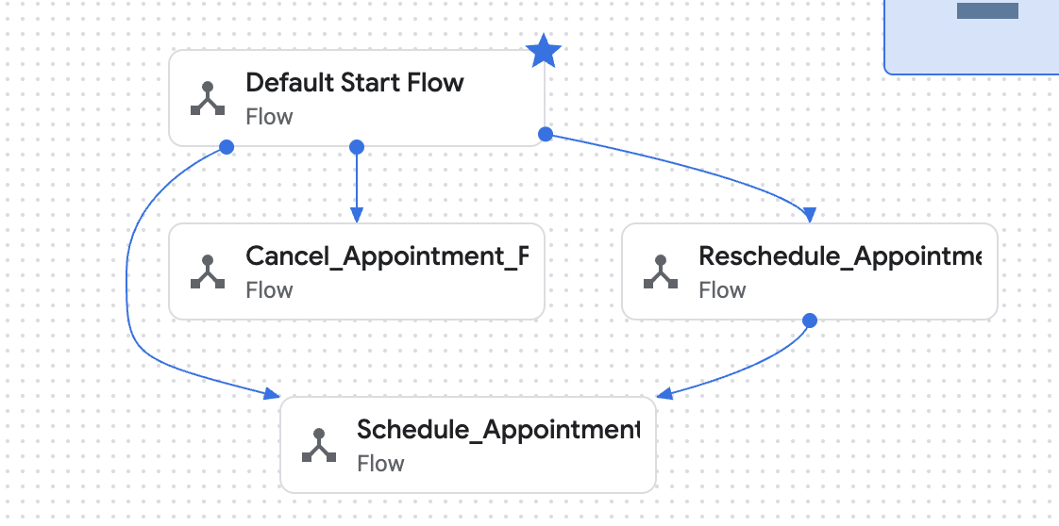

The Conversational AI tool has been developed utilizing the Dialogflow CX platform from Google Cloud with a flow structure. The different key patient-related jobs are developed in individual flows in such a way that there are no conflicts in the Conversational AI tool’s dialogues.

List of Significant Dialogue Flows
- defaultstartflow

- The entry point of the virtual agent.

- Detects high-level intent: Schedule appointment, Reschedule appointment, or Cancel appointment.

- Schedule Appointment Flow

- Captures patient information.

- Gather appointment choices.

- Verifies information and secures the appointment through a confirmation number.

- Reschedule Appointment Flow

- Verifies the user's current appointment based upon the confirmation number.

- Back to the scheduling flow to choose the new date and time.

- Cancelling Appointment Flow

- Verifies the confirmation number.

- Requests confirmation of cancellation and ends or holds the appointment.

- List of all routine sub-flows

Even if our agent now focuses only on three major flows (Schedule, Reschedule, and Cancel), Dialogflow CX has automatic routine sub-flows that serve as supportive building blocks. The routine sub-flows are essential in ensuring that the AI agent remains congruent and complete even if there are no customized versions defined in the project.

Routine Sub-Flows in the System

- Default Welcome Sub-Flow

- Triggered automatically every time the session starts.

- Manages the first greeting and presents the available services (“Schedule, Reschedule, Cancel an appointment”).

- Default Good-bye Sub-Flow

- Triggered when the conversation has come to its natural end or if the user expresses the intention to exit.

- Ends the session politely (“Thank you for contacting GreenCare Clinic. Have a great day!”).

- Confirmation Sub-Flow (Internal Confirmation Pages)

- Used in the Schedule_Appointment_Flow in the Confirm_Summary Page.

- Not a separate flow but functions as a functional sub-flow in our system design.

- Manages Yes/No Confirmations through Confirm_Yes and Confirm_No intents.

- Other Implicit System Sub-Flows

- Error Handler / No-Match Handler

- Triggered if the agent cannot determine the intent or conceptualize inputs from users. Fallback Handler Helps the agent handle unexpected utterances gracefully.

- Description of each dialogue flow, both significant and routine ones.

This section illustrates how each of the dialogue flows in the Patient Scheduling Agent works. For each flow, we outline when and how the process gets initiated, the purpose of the process in terms of the supported user intent, and how the process gets completed.

1. Important Dialogue Flows
1.1 Schedule_Appointment_Flow
i. When/How the flow starts

This process starts when the user expresses the intention to schedule a medical appointment.
Common examples include the following key phrases:

“Schedule an appointment,” “I need to book a doctor’s visit,” or simply “I want to see a doctor.”

The Default Start Flow looks for the intention Schedule_Appointment and directs the user to the Start Page in the Schedule_Appointment_Flow.

ii. The objectives the end-user attempts to realize

The objective of the user in this process is successful appointment booking.
For this purpose, the agent obtains:

- Patient’s personal information (Name, DOB, contact number, insurance)

- Preferences regarding appointment scheduling (type of appointment, reason for appointment, location of appointment

The primary intent expressed here is:

- Schedule_Appointment

The secondary intents that are utilized in confirmation actions are:

- Confirm_Yes

- Confirm_No

iii. How the flow may end
The flow culminates in either of the following ways:

- Successful Completion
- The agent summarizes all collected details.
- User confirms (“Yes”).
- The Finalize_Appointment page assigns a confirmation number and ends the session.
- The system returns to Default Start Flow.
- Correction Loop
- If user responds “No”, the agent routes back to Collect_Appointment_Preferences to fix incorrect details.
- After correcting, the flow resumes and ends as above.

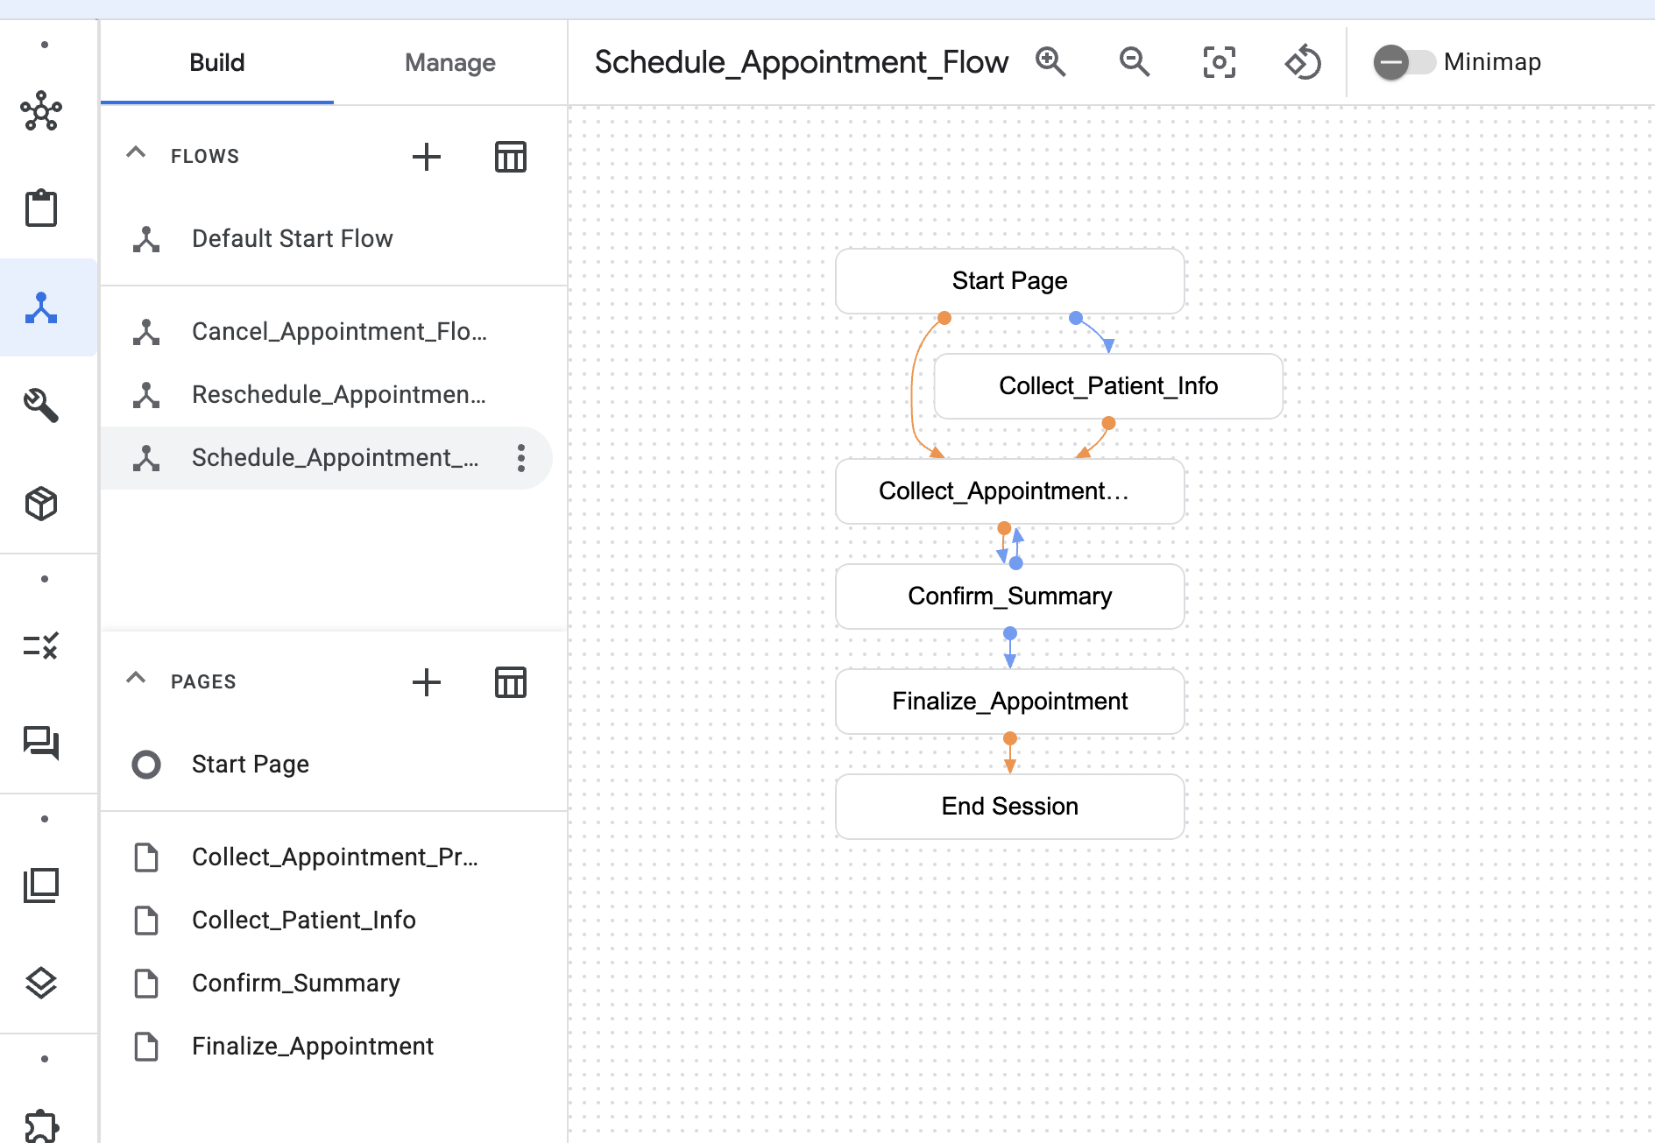

1.2 Reschedule_Appointment_Flow
i. When/How the flow starts
This flow starts when the user expresses intent to change an existing appointment.
Training phrases include:
“Reschedule my appointment,” “Move my appointment,” “Change my time.”
The Default Start Flow recognizes the Reschedule_Appointment intent and moves the user into this flow.

ii. Intent(s) the end-user tries to achieve
The user’s goals include:
- Identifying the appointment they want to reschedule
(by providing confirmation number)
- Updating appointment preferences

Primary intent:
- Reschedule_Appointment

Secondary intents:
- Validation of confirmation number
- Confirmation intents (Confirm_Yes/Confirm_No)

iii. How the flow may end
Two outcomes are possible:
- Successful Reschedule
  - User provides a valid confirmation number.
  - System routes the user back into the Schedule_Appointment_Flow.
  - User selects new date/time, confirms, and receives a new confirmation number.
  - Session ends.
- Failure or Termination
  - If user cannot provide a valid confirmation number, the flow may end with an error message or timeout.

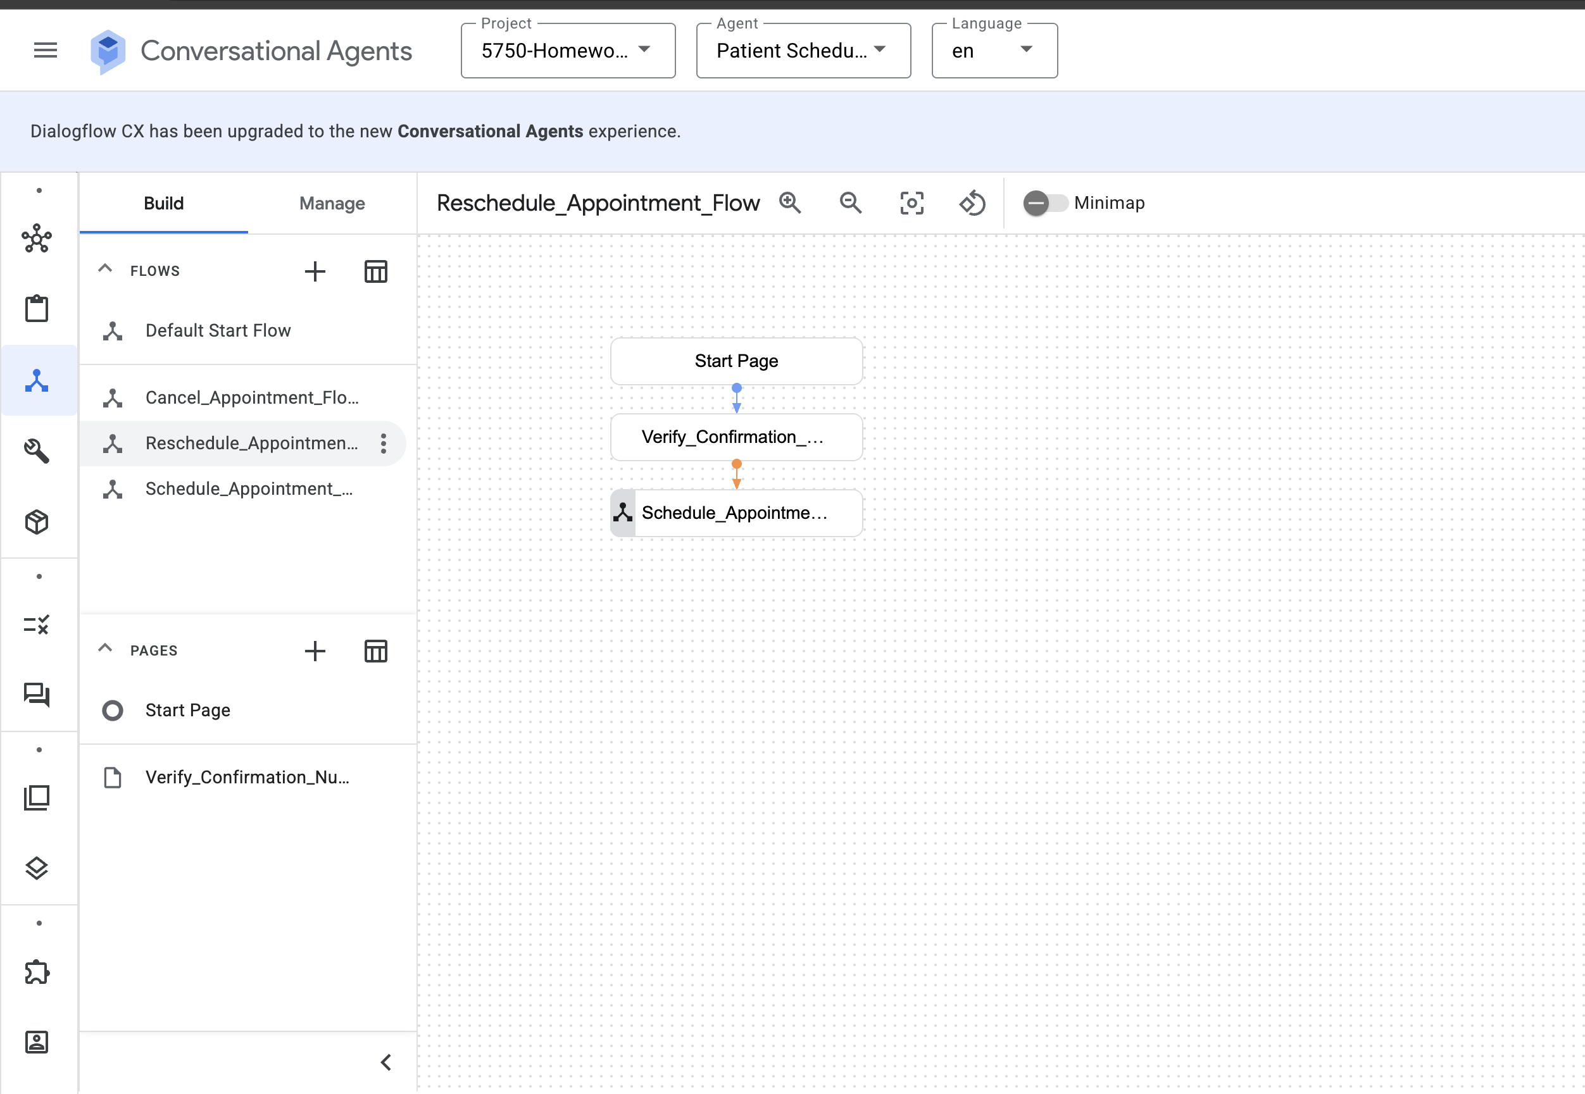

1.3 Cancel_Appointment_Flow
i. When/How the flow starts
This flow begins when the user expresses intent to cancel their appointment.
Triggered by statements like:
“Cancel my appointment,” “I need to cancel,” “Please cancel today's visit.”
The Default Start Flow routes to Cancel_Appointment_Flow when the intent is recognized.

ii. Intent(s) the end-user tries to achieve
The user wants to:
- Cancel an existing appointment
- Provide their confirmation number
- Confirm that cancellation is correct

The primary intent:
- Cancel_Appointment

Secondary intents:
- Confirm_Yes — confirms cancellation
- Confirm_No — aborts cancellation

iii. How the flow may end
Two possible endings:
- Appointment Successfully Canceled
  - User enters a valid confirmation number.
  - Agent asks for confirmation (“Are you sure?”).
  - User responds “Yes.”
  - Appointment is canceled and session ends.
- Cancellation Declined
  - User responds “No.”
  - Agent stops cancellation and ends the session politely.

